**Table 1: programmer**

create table programmer(

name varchar(28),

dob date,

doj date,

sex varchar(1),

prof1 varchar(28),

prof2 varchar(28),

salary int

);

|  |  |  |  |  |  |  |
| --- | --- | --- | --- | --- | --- | --- |
| kathir | 2002-12-29 | 2024-01-21 | m | c | SQL | 3000 |
| bharat | 2001-10-22 | 2024-01-21 | m | python | mangodb | 4000 |
| ajay | 2002-11-12 | 2024-01-21 | m | java | SQL | 3000 |
| balaji | 2003-09-15 | 2024-01-21 | m | java | reactjs | 2400 |
| rohan | 2003-09-26 | 2024-01-21 | m | c | dbms | 3000 |
| kumar | 2002-06-19 | 2024-01-21 | m | python | dbms | 2700 |
| naveen | 2003-04-30 | 2024-01-21 | m | reactjs | nodejs | 3000 |
| shruti | 2001-12-11 | 2024-01-21 | f | js | dbms | 3400 |
| ananya | 2003-01-17 | 2024-01-21 | f | node js | python | 2000 |

insert into programmer values(‘kathir’, ‘2002-12-29’,‘2024-01-21’,‘m’,’c’,SQL’,3000);

insert intoprogrammervalues(‘bharat’,‘20011022’,‘20240121’,‘m’,’python’,mangodb’,3000);

insert into programmer values(‘ajay’, ‘2002-11-12’,‘2024-01-21’,‘m’,’java’,SQL’,3000);

insert into programmer values(‘balaji’, ‘2003-09-15’,‘2024-01-21’,‘m’,’java’,reactjs’,3000);

insert into programmer values(‘rohan’, ‘2003-09-26’,‘2024-01-21’,‘m’,’c’,dbms’,3000);

insert into programmer values(‘kumar’, ‘2002-06-19’,‘20240121’,‘m’,’python’,’SQL’,3000);

insert into programmer values(‘naveen’, ‘2003-04-30’,‘2024-01-21’,‘m’,’reactjs’,’SQL’,3000);

insert into programmer values(‘shruti’, ‘2001-11-11’,‘2024-01-21’,‘f’,’js’,’SQL’,3000);

insert into programmer values(‘ananya’, ‘2002-01-17’,‘2024-0121’,‘f’,’nodejs’,’SQL’,3000);

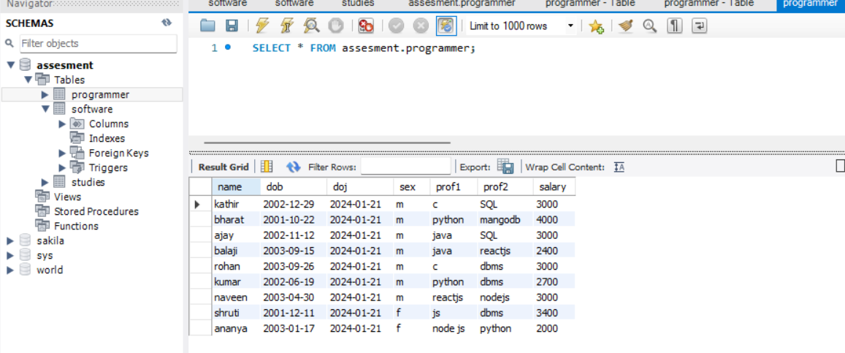

-------------------------------------End of table 1-----------------------------------

**Table 2: software**

Use assessment;

create table software(

name varchar(28),

tittle varchar(220),

devin varchar(20),

scost int,

dcost int

sold int

);

insert into software values('ajay','AI Assistant','python',3000,2700,30);

insert into software values('bala','farm assistant system','reatjs',3300,2800,30);

insert into software values('vishva','encryption od data','python',3700,2900,30);

insert into software values('madhan','weather monitor','java',4000,3700,30);

insert into software values('sharukh','data monitoring system','python',3000,2700,30);

insert into software values('rohith','agri-tech','php',3500,3000,30);

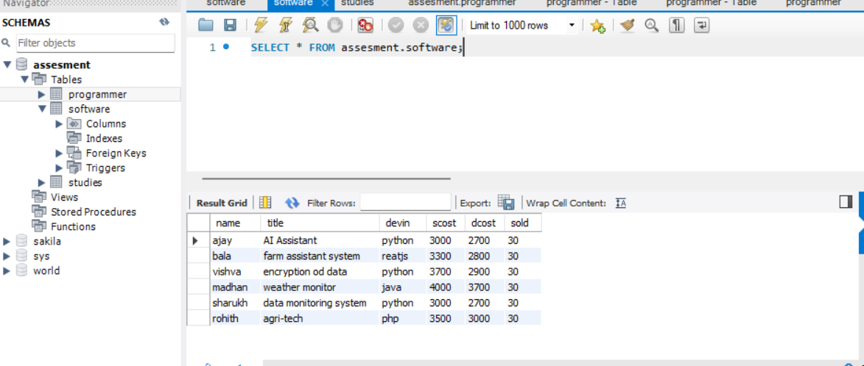

-------------------------------------End of table 2-----------------------------------

**Table 3:studies**

USE assesment;

create table studies(

name varchar(28),

splace varchar(220),

course varchar(20),

cost int

);

insert into studies values('anand', 'villupuram', 'daa' , '20000');

insert into studies values('bala', 'villupuram', 'daa' , '25000');

insert into studies values('chandru', 'chennai', 'php' , '23000');

insert into studies values('deva', 'chennai', 'php' , '27000');

insert into studies values('punith', 'coimbatore', 'java' , '28000');

insert into studies values('saran', 'coimbatore', 'reactjs' , '30000');

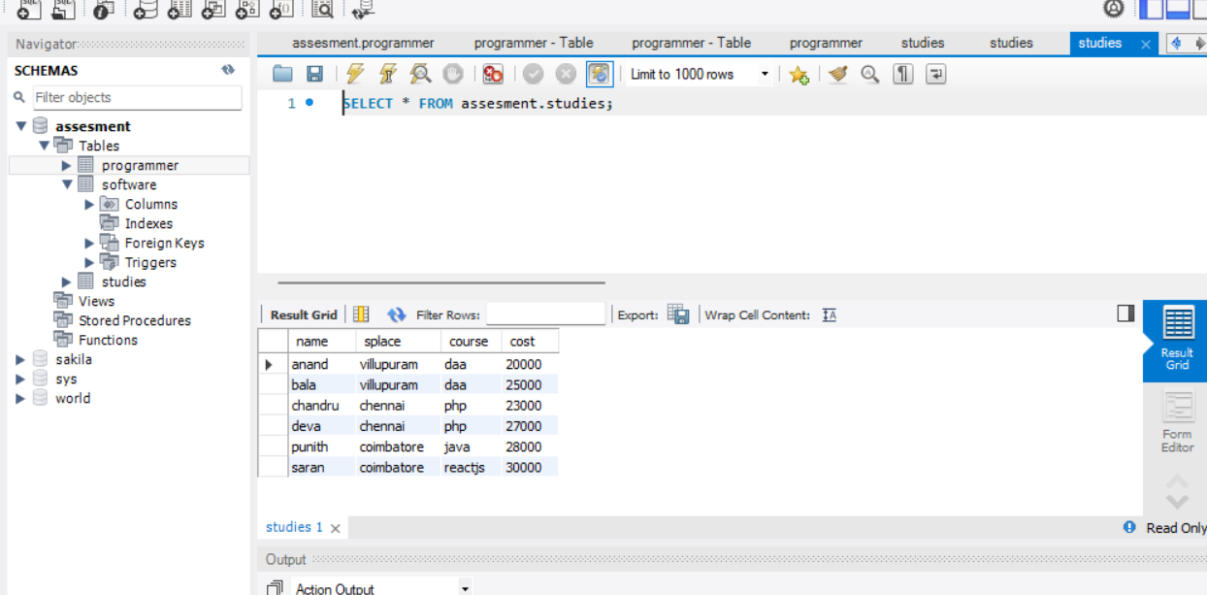

-------------------------------------End of table 3-----------------------------------